**AI Dietician**

**Project Report submitted in the partial fulfillment**

**Of**

##### Bachelor of Technology

##### In

##### Electronics and Telecommunications Engineering

By

# Kavish Shah C047

Manas Tripathi C067

Yash Murarka C068

Under the supervision of

## Name of Guide

(Designation, EXTC Department, MPSTME)

**SVKM’s NMIMS University**

(Deemed-to-be University)



**MUKESH PATEL SCHOOL OF TECHNOLOGY MANAGEMENT & ENGINEERING**

**Vile Parle (W), Mumbai-56**

**2020-21**

**Table of Contents**

|  |  |
| --- | --- |
|  |  |
| **Chapter 1 Introduction**   * 1. **Background**   2. **Motivation and Scope**   3. **Problem Statement**   **Chapter 2 Literature Survey**  **Chapter 3 Methodology and Implementation**  **3.1 Hardware Desciption**  **3.2 Software Description**  **3.3 Model Implemented**  **Chapter 4 Result and Analysis**    **References** |  |
|  |  |
|  |  |

**Chapter 1**

**Introduction**

* 1. **Background of the project topic:**

The online artificial dietician is a bot with artificial intelligence about human diets. It acts as a diet consultant similar to a real dietician. Dieticians are educated with nutrient value of foods. A dietician consults a person based on his schedule, body type, height and weight. The articificial intelligence dietician too asks all this data from the user and processes it.

* 1. **Motivation and scope of the report:**

Many people have a hectic schedule and often lack time to plan a proper diet. It is quite difficult to plan a healthy diet taking all factors into consideration. The project is still in progress and we hope to complete it with sll the modifications.

* 1. **Problem statement:**

An application created on the internet to enter in all your details eg: height,weight,etc. and get a medically tested diet depending on your meal timings for your body type and measure of BMI(Body Mass Index).

**Chapter 2**

**Literature survey**

|  |  |  |  |
| --- | --- | --- | --- |
| **Paper** | **Analysis** | **Implementations** | **Limitations** |
| Application of Artificial Intelligence for Weekly Meal Planning for Children (Aug 2016) | This paper exhibits the advancement of computerized menu arranging framework for a nourishment direction application based on Sustenance Item (Milk, Tea, Coffee) Sustenance Availability(yes, no) Resemblance Factor(low, medium, high) Category(Underweight, Normal, Overweight) General Content of Nutrients(Low, Medium, High) | 1) Generates a nutrient rich diet for children  2) Takes into account availability of products  3) The diet can be changed depending on requirements. | 1) Restricted to children  2) Does not take into account the BMI of the child.  3) The input can be given only as positive or negative. |
| AI DIETICIAN (Mar 2019) | The designed system is useful for common people to maintain their health by taking proper diet. We can develop a system in which if the user is at a remote place, he/she can send details through SMS and system can send diet plan to user. | 1) The system gives diet plan to the users on mobile based on BMI and other factors.  2) This result represents diet plan for obese people.  3)This result represents diet plan for people having pcos disease. | 1) Needs a unique physical measuring Apparatus  2) Does not take into account the availability of food items.  3) Does not take any inputs on basis of the effect from the user |
| Exploring Identifiers of Research Articles Related to Food and Disease using Artificial Intelligence (Nov 2018) | This research is the first report to describe the use of natural language processing and artificial intelligence techniques to extract and analyze data from literature via an automatic classifier. | 1) This paper determines what aspect of the food helps in what relation to the organ.  2) There is a thorough research conducted on basic problems such as heart attack and which foods help in avoiding the same. | 1) Does not give you a balanced diet plan.  2) Theoretical paper with no applications |
| Machine Learning Methods Analysis For Calories Measurement of Fruits and Vegetables | In this paper, we built a measurement method that approximate the amount of calories from an image by computing the volume of the fruit or vegetable from the image and using nutrition facts tables to calculate the amount of calories in fruits and vegetables. | 1) Technique is successfully applied on a variety of food and vegetables.  2) The hardware gives a perfect calorie measurement irrespective of the size and shape. | 1) Requires a physical measuring apparatus  2) The hardware is very complex to build  3) Restricted to fruits and vegetables and not cooked meals. |

**Chapter 3**

**Methodolgy and Implementation**

**3.1 Hardware description:**

* The current project model is purely software based.
* In future, additional hardware integration is possible. (Fitness bands, weighing scales, BFP callipers, etc)

**3.2 Software description, flowchart / algorithm:**

* The project is 40% front-end, 15% database and 45% back-end logic and algorithms.
* Front-end technologies that will be used are Adobe XD, HTML, SCSS, JavaScript, JSON, AJAX and several libraries of each. There are few more services which will be used for development.
* Back-end technologies like Python with Django (web) and TensorFlow (deep learning) will be used. Other services like hosting tools, etc. Would be used as well.
* Database could be a SQL or a NoSQL database based on which suits best for our hosting service.

**3.3 Model Implemented:**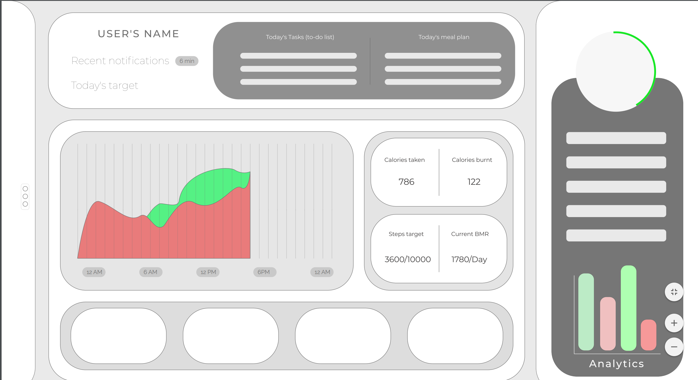

**Chapter 4**

**Results and Analysis**

This shall include a evaluation and investigation carried out.

**References**

* AI DIETICIAN :YEAR 2019 Prajakta Dadasaheb Jadhav, Apurva Madan Sinnarkar, Sneha Vaideswaran & Prof. Bharati.M. Narute Department of Electronics and Telecommunication Engineering, Modern Education Society’s College Of Engineering Pune, India.
* Application of Artificial Intelligence for Weekly Meal Planning(YEAR 2016) for Children 1 Sanchit Kalra, 2Garvit Arora and 3Rajat Aggarwal, 1,2,3Student, 1,3Department of Textile Technology, 2Department of Production & Industrial Engineering, 1 Indian Institute of Technology, Delhi, India
* Machine Learning Methods Analysis For Calories Measuremnt of Fruits and Vegetables

5 th IEEE International Conference on Signal Processing, Computing and Control (ISPCC 2k19), Oct 10-12, 2019, JUIT, Solan, India

* <http://ieeexplore.ieee.org/xpl/articleDetails.jsp?tp=&arnumber=4635195&queryText%3DArtificial+Intelligence+Dietician>
* <http://ieeexplore.ieee.org/xpl/articleDetails.jsp?tp=&arnumber=4630615&queryText%3DArtificial+Intelligence+Dietician>
* <http://ieeexplore.ieee.org/xpl/articleDetails.jsp?tp=&arnumber=4804025&queryText%3DArtificial+Intelligence>